We Are The Same
Recipes
from Italy, the Netherlands, Norway and Poland

3. Add sliced onion and fry again.
4. Put 1 litre water on stove, add Mushrooms and onion, boil 20 min.
5. Use salt and pepper to taste and add cream.
6. Add sauce to top off noodles.

Dessert: Pancakes with jam
Ingredients:
- 2 glasses of milk
- ½ glass of water
- 2 eggs
- Sugar
- 2 glasses of flour
- Oil to fry
- Jam

- Put milk to bowl
- add water, eggs, sugar, salt, flour and milk( optional oil).
- Fry pancakes, and put on plate.
- Grease the pancakes with jam and roll it.

17

Main course: Silesian noodles with mushroom sauce
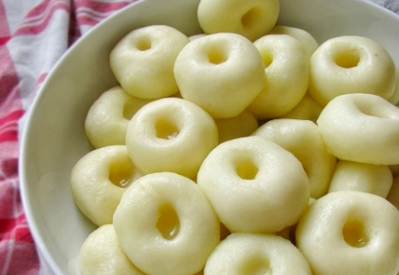

Silesian Noodles
Ingredients:
- 0,5 kg cooked potatoes
- Potato flour
- Egg
- Salt

- boil, peel and mill potatoes
- add flour and salt
- knead the dough, and form small balls and make holes with your finger
- put noodles to boil and add salt water
- cook until they are ready
- use slotted spoon and dry noodles, later put them on a plate

Mushroom sauce
Ingredients:
- 0.5 kg mushrooms
- 4 tablespoon of butter
- 200 ml cream
- Salt and pepper

1. Wash, peel and dry mushrooms.
2. Cut in slices and fry in butter.

16

Table of contents

Italy 6
First course: Octopus and potato salad 6
Main course: Pasta in the oven 10
Dessert: Tiramisu 13
The Netherlands 15
First course: Rye bread with raw herring 17
Main course(s): “Boerenkool” & “Hutspot” 18
Boerenkool (mashed potatoes and kale) 18
Hutspot (Dutch carrots, potatoes and onions) 19
Dessert: Sugar bread French toast 16
Norway 15
First course: Smoked salmon with scrambled eggs 15
Main course: Reindeer stew 12
Dessert: Angels food 11
Poland 12
First course: Fish in carrot 8
Main course: Silesian noodles with mushroom sauce 4
Dessert: Pancakes with jam 3

1

Italy

First course: Octopus and potato salad
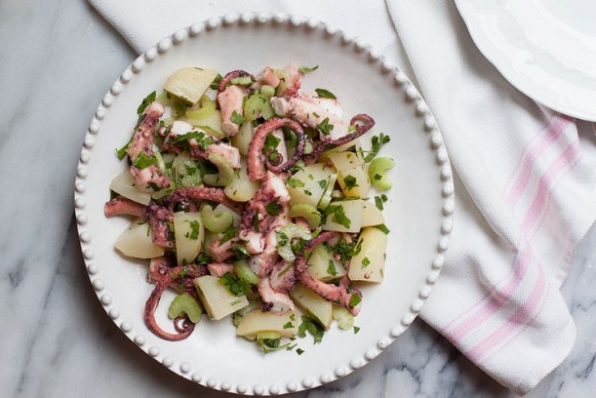

Ingredients (4 servings):
- 2 pound octopus, ( 1 kg) cleaned (fresh or frozen, frozen is preferable as it will be more tender when cooked)
- 1 pound Yukon Gold potatoes, cleaned
- 4 tablespoons extra-virgin olive oil
- Fresh squeezed juice of 1 large lemon (about 2 tablespoons)
- Fine sea salt, to taste
- Freshly ground black pepper, to taste
- 4 tablespoons finely chopped flat-leaf parsley, plus leaf for garnish
- 1 celery rib, thinly sliced lemon wedges, for garnish

optional: 1 garlic clove, minced
optional: 1 tablespoon finely chopped fresh mint leaf
optional: ¼ teaspoon red chili pepper flake

2
3. When the vegetables are boiling, you can fry the fish: coat it in flour and fry in batches with gold in hot oil.
4. Fry a little broth (about half a cup) and mix the tomato paste in it.

5. Cut onion and leek into half-slices and glaze in a pan on oil, add cooked vegetables together with the decoction and concentrate, mix and boil. Season to taste with salt, pepper, paprika, basil and oregano.

6. Place the hot vegetables on the fried fish in a glass or ceramic dish. Cool, cover and cool in the fridge.

7. The best way to prepare the food in advance is to make it taste good. In addition, vegetable juices will thicken. Before serving, garnish with parsley.

15

Poland

First course: Fish in carrot

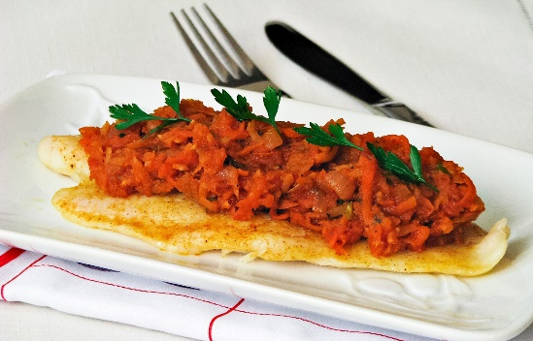
Ingredients:
- 800 g white fish fillets, cod, hake, miruna, pollock, frozen or social
- 1/2 kg of carrot
- 150 g parsley
- 100 g of celery
- 1 large onion
- 1 small leek (white part)
- 3 glasses of boiling water
- spices: 1 teaspoon of salt, 3 allspice, 1 bay leaf, 1/2 teaspoon: pepper, sweet pepper, basil, oregano
- 1 small jar (100 g) of tomato concentrate
- Vegetable oil for frying, rice, sunflower

1. To thaw and dry thoroughly with paper towels. Cut into pieces, sprinkle with salt, pepper, put away.

2. Peel the carrot, parsley and celery and grate on a thick-mesh vegetable grater. Put into a pot and pour in boiling water, add salt. Cook for 15 - 20 minutes with the lid open. At the end, add the allspice and bay leaf.

14
Steps to make it :
- Place the octopus in a large pot and cover with cold water. Add 2 teaspoons of fine sea salt and bring just to a simmer over medium heat. Let barely simmer over gentle heat just 3-5 minutes; the octopus will be moist and have a slight chew (octopus can either be just quickly cooked, as suggested here, for a slightly chewy but still tender consistency or slowly braised for about 1 hour over a very low flame. For a salad such as this, the quick method with a firmer texture is preferable, in my opinion). Remove from heat and set aside to let cool.
- Meanwhile, put the potatoes in a large saucepan, cover with cold water, add 1 teaspoon of fine sea salt, and bring to a boil over high heat. Boil until tender, about 30 minutes. Drain and let cool slightly. Peel the potatoes and cut them into 1/4-inch-thick slices.
- In a medium bowl, toss the still-warm potato slices with the olive oil, lemon juice, and salt and pepper to taste. Add the parsley and celery and stir to combine.
- Cut the octopus into 1-inch chunks and add to the potato mixture. Stir to combine. If using, add the optional garlic, mint, and chili pepper flakes and combine.
- Serve at room temperature, each serving accompanied by a lemon wedge and crusty bread. You can chill the salad in the refrigerator for a few hours before serving, but let it return to room temperature before serving to allow the flavours to shine fully.

3

Main course: Pasta in the oven
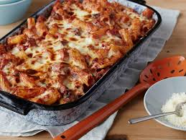

Ingredients:
- 1 (16 ounce) package penne pasta
- 1 tablespoon olive oil
- 1 onion, finely chopped
- 3 cloves garlic, minced
- 3 (6 ounce) cans tomato sauce
- 2 tablespoons tomato paste
- 3/4 cup heavy whipping cream
- 1/2 cup grated Parmesan cheese
- salt and freshly ground black pepper
- 1 pinch white sugar
- 1 pound cherry tomatoes, halved
- 1 1/4 cups shredded mozzarella cheese
- 1 small bunch fresh basil, finely chopped

1. Bring a large pot of lightly salted water to a boil. Add penne and cook, stirring occasionally, until tender yet firm to the bite, about 11 minutes. Drain, reserving 1 cup of cooking water.
2. Heat olive oil in a large skillet over medium heat and cook onion until soft and translucent while penne is cooking, about 5 minutes. Add garlic and cook an additional 30 seconds. Stir in tomato sauce

4

Dessert: Angels food
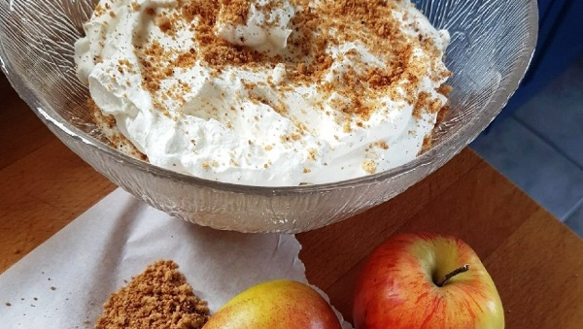

Ingredients:
- about 20 apples
- about 20 dl cream
- sugar
- cinnamon
- water

- Peel and cut apples into cubes, remove the core.
- Have the dice in a saucepan together with four tablespoons of sugar and all the water. The boil for the apples is tender and starts to moss. Cool. You can also buy ready-made apple sauce. Then use 1, 5 dl sauce for this recipe.
- Crush cookies into crumbs
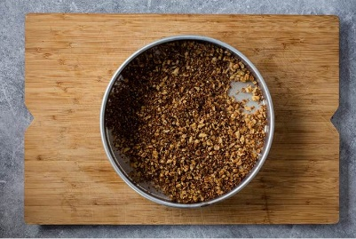

- Whip the cream airy.
- Arrange apple, cream and crushed cookies in bowls or glass and serve immediately.

13

Main course: Reindeer stew
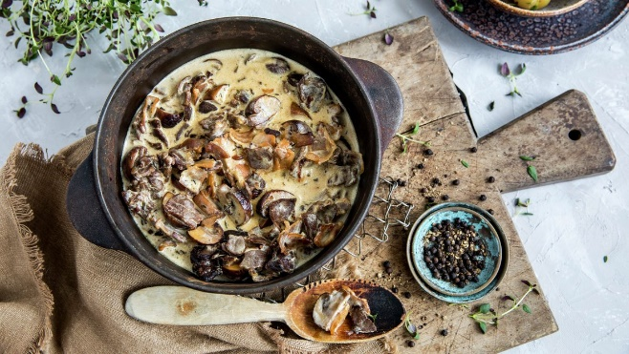

Ingredients:
- about 2000 g thinly sliced frozen reindeer meat
- coarsely ground pepper to taste
- juniper berries
- about 2 litres of double cream
- about 1000 grams of champignon or wild mushrooms
- 10 table spoons butter
- about 5 dl of soy sauce or bouillon
- Norwegian goat cheese
- about 3 kg potatoes

- Heat an iron frying pan until it's very hot. Put in butter and let it get dark brown. Put the reindeer meat in and fry until it's developed a nice, brown crust,
- Add the mushrooms and fry for a few minutes till they also are golden.
- Put in the soy sauce or bouillon and juniper berries and stir for 2-3 minutes, then add the cream and the goat cheese. Cook until it thickens.
- Boil potatoes
- Mash potatoes and add water or milk til it gets an airy consistence.
- Serve with homemade mashed potatoes.

12

and tomato paste and cook until slightly reduced, about 5 minutes. Add cream and Parmesan cheese and season with salt, pepper, and sugar.
3. Preheat oven to 400 degrees F (200 degrees C). Grease a baking dish.
4. Stir some pasta cooking water into the sauce and add cooked penne. Remove from heat and stir in cherry tomatoes, 1/2 the mozzarella cheese, and basil. Pour penne mixture into the prepared baking dish and cover with remaining mozzarella cheese.
5. Bake in the preheated oven until cheese is melted, about 20 minutes.

Dessert: Tiramisu
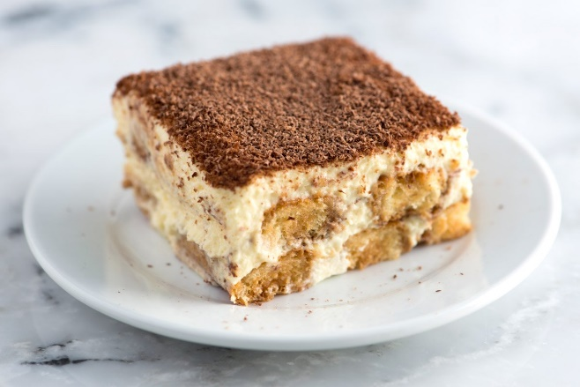

Ingredients (6 servings):
- 4 eggs
- 4 tablespoons of white sugar
- 2 little cups of expresso
- 2 tablespoons of rum or marsala (optional)
- 250g (1/2 lb) of mascarpone
- unsweetened cocoa powder
- 30 Savoiardi ladyfingers

5
- First of all, make the coffee and add rum or marsala (optional) then set aside and let it cool. Separate egg whites from yolks and remember that in order to whip the egg whites there should not be any trace of yolk.
- Take a bowl and whip the egg whites until stiff: you will get at it when the egg whites will not move if you turn the bowl over. When ready, set aside.
- Now in another bowl (or the clean same one) whisk the egg yolks with 4 tablespoons of sugar using an electric mixer until pale and smooth, 3 to 5 minutes.
- When ready add mascarpone cheese in 2 or 3 additions, stirring well to combine.
- Then whisk the cream SLOWLY with the electric mixer. Now add stiffen egg whites a little at a time.
- Mix the cream very slowly until it’s ready.
- Meanwhile dip quickly Savoiardi Ladyfingers into the coffee, for 1 sec . IMPORTANT! Cookies should not engage too much coffee, otherwise your Tiramisu will turn out too soggy. Then place them in the bottom of a 6×9 inch casserole.
- Spread half of the mascarpone cream on top of the ladyfingers and top with another layer of biscuits.
- Finally spread the remaining mascarpone cream on top of the last layer of the ladyfingers and sprinkle with cocoa powder. Let rest 2 to 3 hours in the refrigerator before serving.

6

Norway

First course: Smoked salmon with scrambled eggs
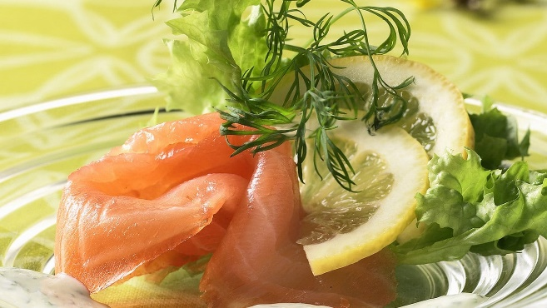

Ingredients:
- about 30 eggs
- water
- chives
- salt
- smoked salmon
- oil or butter
- salad
- lemon
- dill

- Whisk eggs together with water, salt and pepper.
- Stir in chopped chives. Fry on medium heat until it starts to become a solid mass.
- Cut the salmon in slices.
- Add lettuce leaves on plates and smoked salmon on top, add some scrambled eggs, and decorate with lemon slices and dill.

11

Dessert: Sugar bread French toast
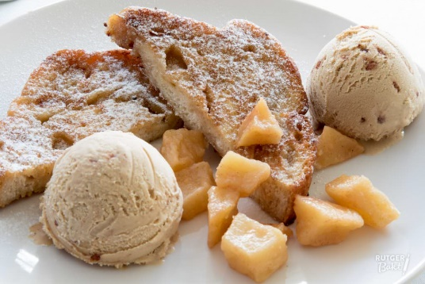

Ingredients (6-8 portions):
- 2 eggs
- 250 ml milk
- 6-8 slices of sugar bread
- Butter (to bake in)
- 75 gr sugar
- 1 teaspoon cinnamon
- Cinnamon flavoured ice
- Optional: caramelised apple

- Add the eggs and milk to a bowl and mix
- Soak the slices of bread in the mix, but not too long. Don’t let it fall apart.
- Melt some butter in a frying pan and bake the bread
- Mix sugar with cinnamon and sprinkle the toast with it
- Serve the toast lukewarm with the cinnamon flavoured ice (and the caramelised apple)

10

The Netherlands

First course: Rye bread with raw herring
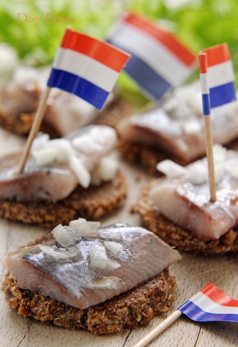

Ingredients:
- Salt herring
- Rye bread
- Onions (optional: pickles)
- (tooth)picks

- Cut the onion in small dices
- Cut the rye bread in small pieces
- Put the herring on the rye bread and garnish with raw onion
- Pin it together with a (tooth)pick

7

Main course(s): “Boerenkool” & “Hutspot”

Boerenkool (mashed potatoes and kale)
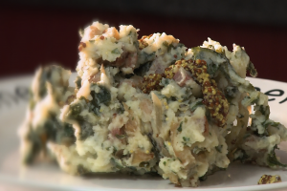

Ingredients (10 servings):

- 3.75 kg potatoes
- 5 onions
- 2 ½ twigs rosemary
- 625 gr bacon (diced)
- 1250 gr kale
- 250 gr butter
- 500 ml milk
- Optional: mustard
- 1 masher

- Peel and clean the potatoes. Boil it in a pan with a little water and salt. Boil them in about 15 minutes.
- Peel and cut the onions. Chop the rosemary. Bake the bacon in a dry pan and add the rosemary and onions. After a while, add the kale and braise it for about 15 minutes until it’s shrunk.
- Heat the milk and butter in a pan. Smash the potatoes and add the heated milk and butter. Stir until you have a smooth mix. Add salt and pepper.
- Add the kale mix to the mashed potatoes and stir well.
- Serve with smoked sausage or meatball (and/or mustard).

8

Hutspot (Dutch carrots, potatoes and onions)
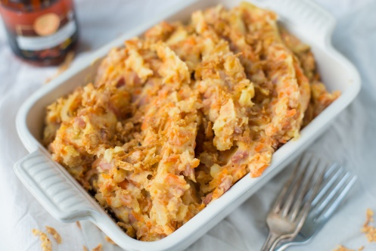

Ingredients (10 servings):
- 2 pounds carrots, peeled and cut into small chunks
- 2 pounds yellow onions, diced
- 2 pounds Yukon Gold potatoes, peeled and cut into quarters
- ½ pound chunk of smoked bacon
- 2 tablespoons butter
- ½ teaspoon salt

- Place carrots and onions into a large pot. Cover with 2 cups water.
- Place chunk of bacon on top. Cover and cook 35 to 40 minutes, until onions and carrots are soft.
- Remove bacon. Drain and reserve cooking liquid. Set cooked carrots and onions aside.
- Boil potatoes in the same cooking liquid, cooking them until they fall apart.
- Mash potatoes with carrots and onions. Stir in butter and salt.
- Slice bacon into thin pieces, and serve alongside or on top of the hutspot.
- Serve with beef braised in brown butter, a meat ball or smoked sausage.

9

